## INTRODUCTION

## 1. INTRODUCTION

### ASP .NET MVC:

The Model-View-Controller (MVC) architectural pattern separates an application into three main components: the model, the view, and the controller. The ASP.NET MVC framework provides an alternative to the ASP.NET Web Forms pattern for creating Web applications. The ASP.NET MVC framework is a lightweight, highly testable presentation framework that (as with Web Forms-based applications) is integrated with existing ASP.NET features, such as master pages and membership-based authentication.

### MODEL:

 Model objects are the parts of the application that implement the logic for the application's data domain. Often, model objects store and retrieve model state in a database. For example, a Product object might retrieve information from a database, operate on it, and then write updated information back to a Products table in a SQL Server database.

In small applications, the model is often a conceptual separation instead of a physical one. For example, if the application only reads a dataset and sends it to the view, the application does not have a physical model layer and associated classes. In that case, the dataset takes on the role of a model object.

### VIEW:

  Views are the components that display the application's user interface (UI). Typically, this UI is created from the model data. A view can be any output representation of information, such as a chart or a diagram. Multiple views of the same information are possible, such as a bar chart for management and a tabular view for accountants. An example would be an edit view of a Products table that displays text boxes, drop-down lists, and check boxes based on the current state of a Product object.

### CONTROLLER:

The controller accepts input and converts it to commands for the model or view.  These are the components that handle user interaction, work with the model, and ultimately select a view to render that displays UI. In an MVC application, the view only displays information; the controller handles and responds to user input and interaction. For example, the controller handles query-string values, and passes these values to the model, which in turn might use these values to query the database.

## Location Mapping/Restacking Tool:

## This tool provides a single window view to help real estate management. It helps to strategize the move globally, across facilities to make optimum and precise usage of available space. It helps senior managers to identify the location needs and plan accordingly. It also makes them to review existing resource or group or an organisation unit, current location. This tool will also be a great help during emergency relocation of teams. Region based administration roles can be created and region based location can be maintained separately. Major restacking can be done with minimal effort. Details/Extract of this application can be provided to other application as services. This tool deals with Digital Workplace and Mysource to explore where this tool best can be applied for enterprise usage.

## PROBLEM STATEMENT

**2. PROBLEM STATEMENT**

The location mapping or restacking of employees/teams within the organization was currently maintained using Excel files.  As it is manual process, there was problem in effectively managing the available space and time consuming. In addition, there was no central control or reporting capabilities. In order to overcome these, we created service for mapping location and restacking using MVC .NET framework.

## SYSTEM REQUIREMENTS

### 3. SYSTEM REQUIREMENTS

* 1. **HARDWARE REQUIREMENTS**

The minimum hardware configuration of the system on which the project was developed is as follows:

* + - Processor : Intel(R) Core(TM) 3.2 Ghz
    - CPU clock : 450 Mhz
    - RAM : 8 GB
    - HardDisk : 40 GB
    - Keyboard : Any type
    - Mouse : Any type
    - Monitor : Any type/Color Monitor preferable

### 3.2 SOFTWARE REQUIREMENTS

* Operating System : Windows 7
* Language Used : C sharp(Visual Studio 2013)

## LITERATURE REVIEW

**4. LITERATURE REVIEW**

**4.1 LOCATION MAPPING/RESTACKING**

# [J.A. Castellanos](http://ieeexplore.ieee.org/search/searchresult.jsp?searchWithin=%22Authors%22:.QT.J.A.%20Castellanos.QT.&newsearch=true), [J.M.M. Montiel](http://ieeexplore.ieee.org/search/searchresult.jsp?searchWithin=%22Authors%22:.QT.J.M.M.%20Montiel.QT.&newsearch=true) , [J. Neira](http://ieeexplore.ieee.org/search/searchresult.jsp?searchWithin=%22Authors%22:.QT.J.%20Neira.QT.&newsearch=true) , [J.D. Tardos](http://ieeexplore.ieee.org/search/searchresult.jsp?searchWithin=%22Authors%22:.QT.J.D.%20Tardos.QT.&newsearch=true) (1999) used A Probabilistic Framework for Simultaneous Localization and Map Building complete framework for the simultaneous localization and map building problem for mobile robots: the symmetries and perturbation map, which is based on a general probabilistic representation of uncertain geometric information. A complete experiment with a Lab Mate/sup TM/ mobile robot navigating in a human-made indoor environment and equipped with a rotating 2D laser rangefinder. Experiments validate the appropriateness of our approach and provide a real measurement of the precision of the algorithms.

# A.Ward, A.Jones, A.Hopper (2002) proposed A new location technique for the active office for the configuration of the computing and communications systems found at home and in the workplace is a complex task that currently requires the attention of the user. Researchers have begun to examine computers that would autonomously change their functionality based on observations of who or what was around them. By determining their context, using input from sensor systems distributed throughout the environment, computing devices could personalize themselves to their current user, adapt their behavior according to their location, or react to their surroundings. The authors present a novel sensor system, suitable for large-scale deployment in indoor environments, which allows the locations of people and equipment to be accurately determined. We also describe some of the context-aware applications that might make use of this location information.

**4.2 EXISTING SYSTEM**

Initially, the Location mapping/restacking is done manually using Excel Macros. A macro is a piece of programming code that runs in Excel environment and helps automate routine tasks. Macros include importing the data and formatting it to meet your business reporting requirements.

Entering the data into Excel manually can take a very long time especially if having a lot of data to enter. The amount of time it takes to enter the data can be inefficient which leads to potentially costly inattentiveness.

**Using only one file can make the file size very big and the program runs slowly. So, we might have to break it into smaller files. So,** **there is an increased risk in Excel data** **being lost.**

**While** **the spreadsheets** **are ideal for creating one time analysis, they become problematic as** **the data** **grows and evolves over time. As new rows and columns get added, the summary ranges** may **need to be modified or new ones created,** **the data** **and** **the formulas** **are not consistently updated, and these mistakes lead to bad results and decisions.**

### LIMITATIONS IN THE EXISTING SYSTEM

There is no separation in input, processing and output in the application. Both data and business logic were present in the same file which makes the application inefficient to handle.

### NEED FOR NEW SYSTEM

To reduce the time consumption and the separation of the input, processing, output in the application.

### PROPOSED SYSTEM

1. In the iLoc tool, there are types of Login: Administrator Login and Employee Login.
2. If the Employee gets logged in, he/she can only view the other employee’s information along with the location of them.
3. If an administrator gets logged in, he/she can do prioritized works such as

* Register Location
* Register Floor Map
* Add other employee’s location
* Delete other employee’s location
* Modify other employee’s location
* Reallocate employees location

1. The proposed system is in such a way that input, processing and the output is separated by means of Model, View and Controller.
2. A Controller returns a Json or a View. A View basically displays an interface to the user such that it may be a list or particular details.
3. A Model is similar to a class but there exists a DAL (Data Access Layer) where it interacts with the database and displays the result in the view.
4. In addition to DAL, we can have BLL (Business Logic Layer) that encodes the real-world business rules which determine how data can be created, stored and changed.
5. We can have entity-framework where we don’t need to have the code to get interacted with the database. Instead everything is automated using LINQ (Language integrated Query) – Uniform programming model for any kind of data.

### BENEFITS OF NEW SYSTEM

* Generic to enable using the tool for any kind of facility Offices, Parking lots, etc.
* Enhance operational efficiency.
* Eliminates/Minimize UDT usage and leverage optimization of available space.
* Major restacking can be done with very minimal effort.
* Region based administrators roles can be created and region based location can be maintain separately
* Availability reports to review and strategize resource movement across cross facilities.
* Details/Extract can be provided to other application as services.

## DESIGN METHODOLOGY

**5. DESIGN METHODOLOGY:**

* 1. **BLOCK DIAGRAM**

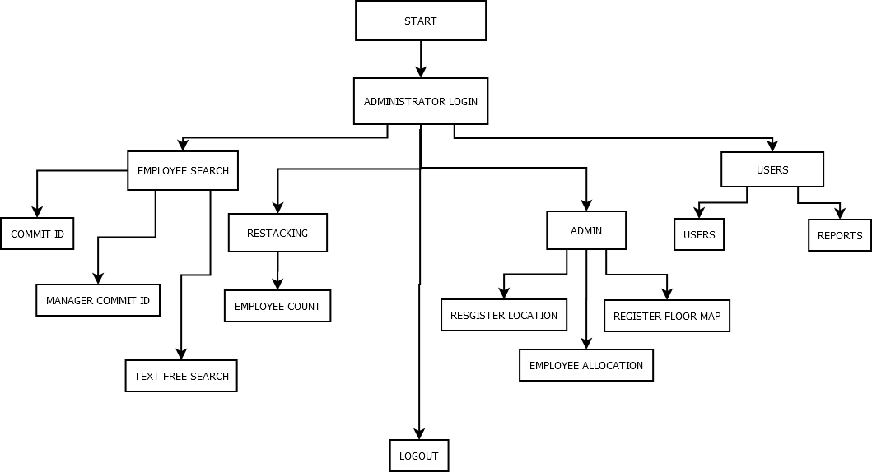

Figure 5.1

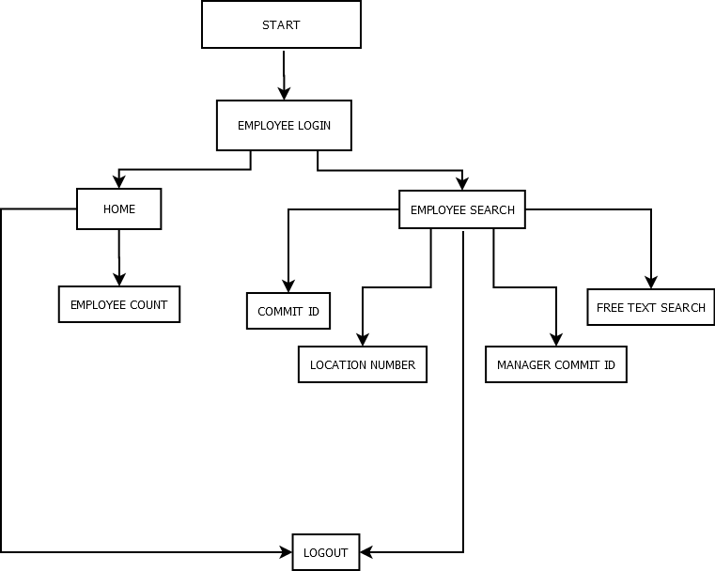

Figure 5.2

### MODULES

### 5.2.1 LOGIN:

### Login in the iLoc tool is based on Membership. ASP.NET provides built in controls to manage Membership in Web Applications. All these controls use ASP.NET providers that are loaded via web.config  file. Membership provider and Role provider allow a complete system to maintain user’s information, authenticate and authorize the users.

### 5.2.2 ADMINISTRATOR MODULE:

### Register Floor Map-Option to add new location map into the tool. Floor map image file can be any bit map file`

### Register Location-Option to add new location on the newly added map. Tool has the option to insert consecutive location numbers by a single Click

### Employee Allocation-Option to allocate location to the Employee by clicking the unallocated location and provide employee commit id.

### Employee Search- Search employee’s location by providing commit id.

### Employee, Group Search-Search employee’s or group/Division by location by manager id

### Restacking-Based on count of employees, Tool will provide the best available locations and provides a single view.

### User Administration-To create application level users and assign roles

### 5.2.3 EMPLOYEE MODULE:

### Employee Search- Search employee’s location by providing commit id.

### Employee, Group Search-Search employee’s or group/Division by location by manager id

**RESULTS AND DISCUSSIONS**

**6. RESULTS AND DISCUSSIONS**

The below figure depicts the Login Page.

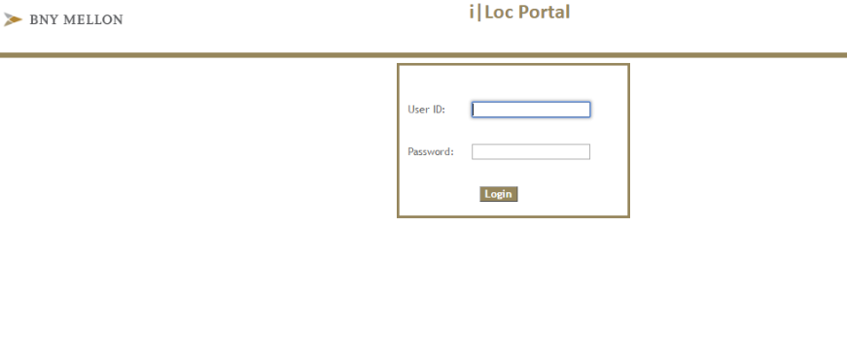

Figure 6.1



Figure 6.2

This figure shows the home page with the count of employees in a specified location.

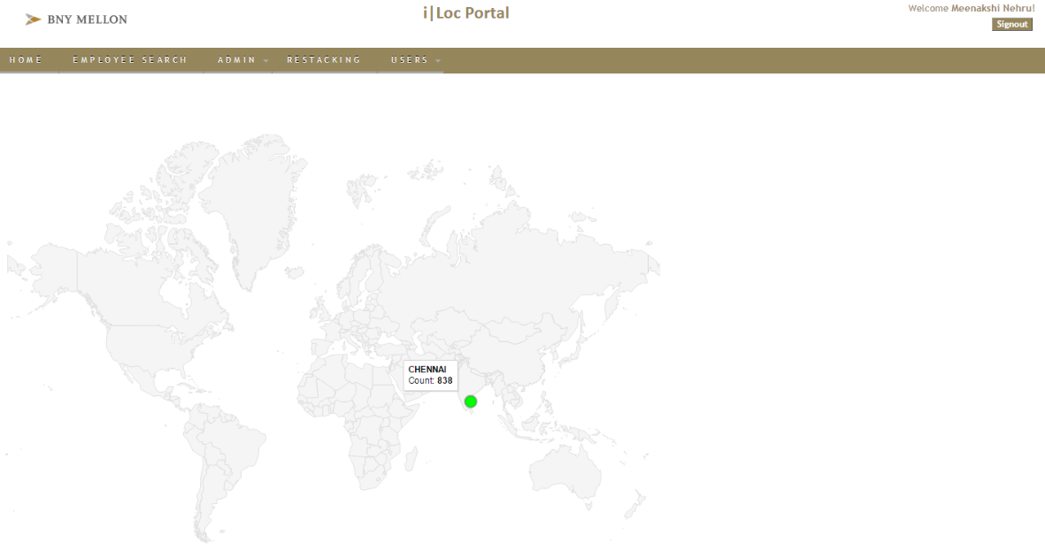

Figure 6.3

This figure shows that the employee search can be done by means of Commit ID, Location Number, Manager Commit ID or Department

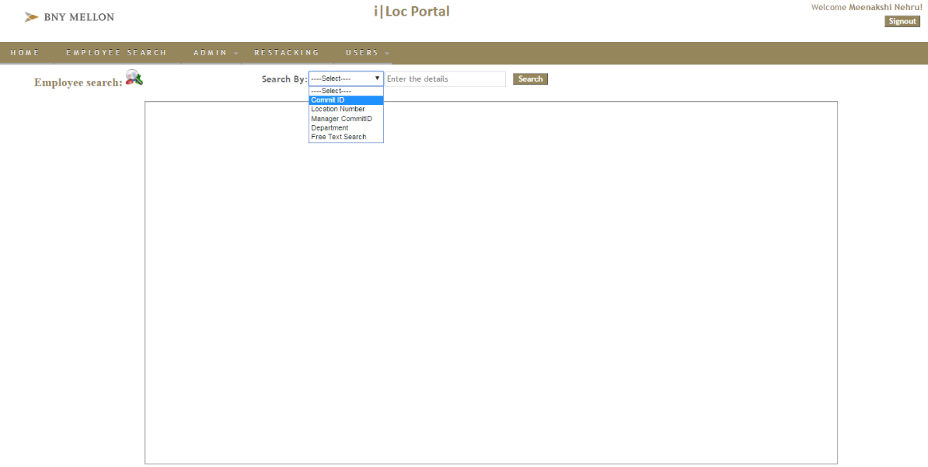

Figure 6.4

The below figure indicates the employee search by means of Commit ID.

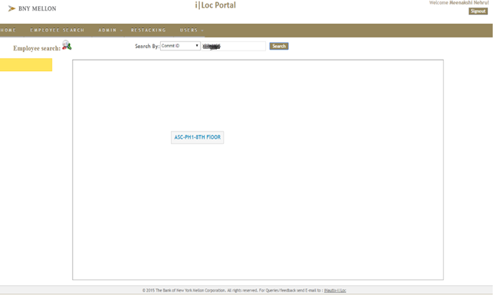

Figure 6.5

The below figure shows the employee’s location details.

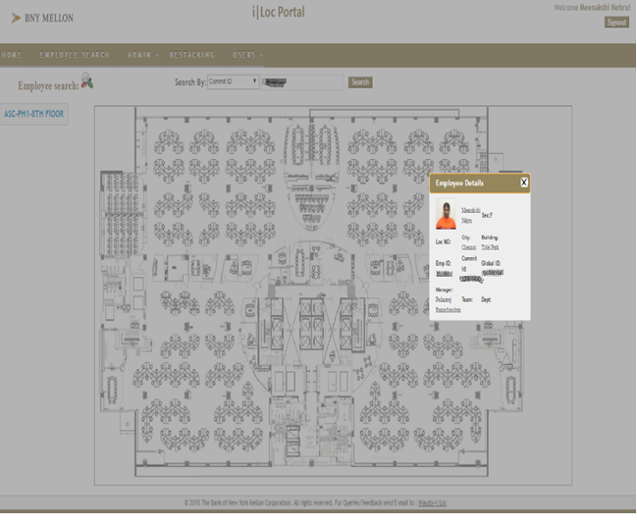

Figure 6.6

The below figure shows the employee search through Manager Commit ID.

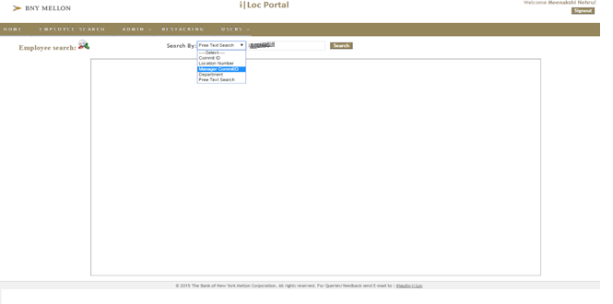 Figure 6.7

\

This figure shows the employees allotted under the mentioned manager.

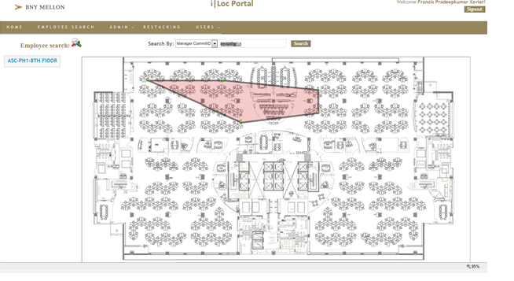 Figure 6.8

This figure shows the administrator’s role i.e. Register Floor Map, Register Location and Employee Allocation.

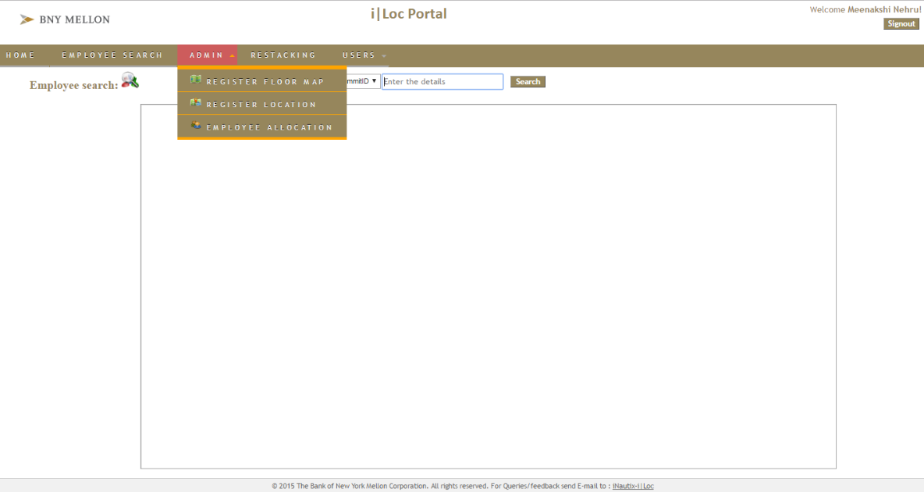

Figure 6.9

The below figure depicts the Floor Map registration.

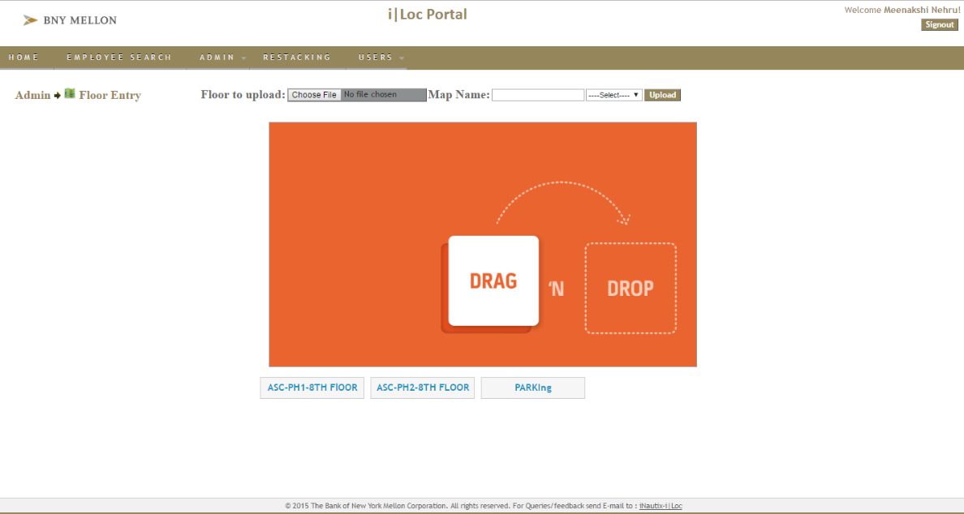

Figure 6.10

This figure depicts the location registration.

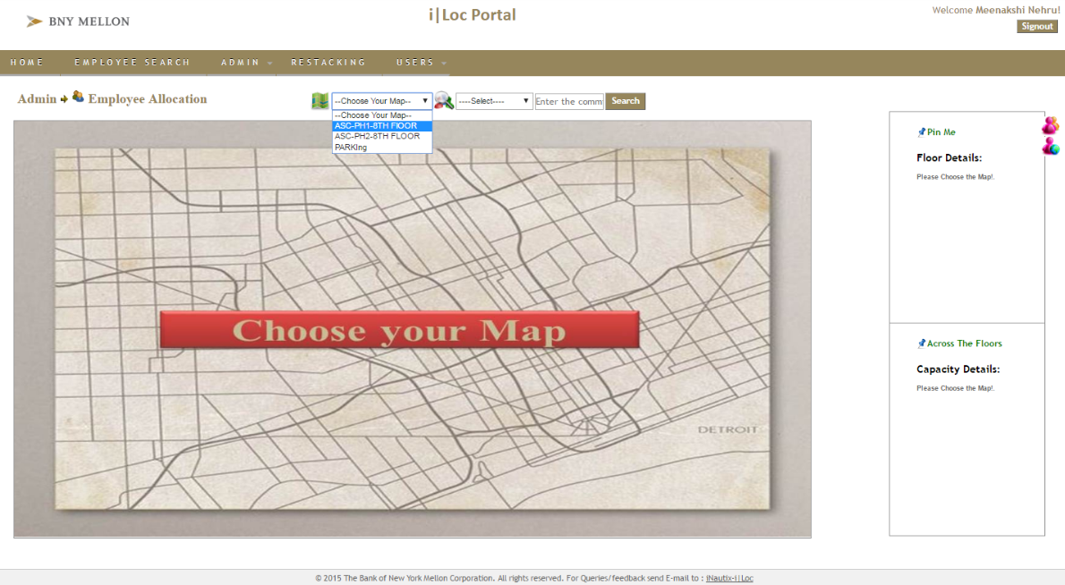

Figure 6.11

This figure depicts the employee allocation.

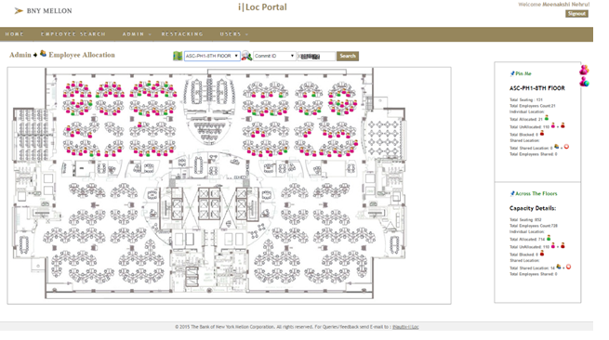

Figure 6.12

The below figure shows that the employee successfully allocated and we can also reallocate them.

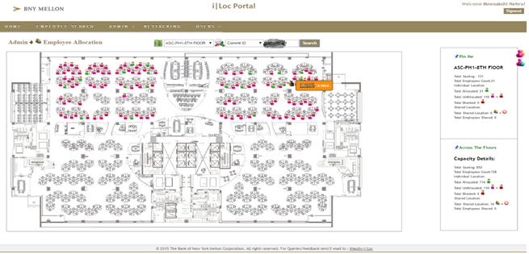Figure 6.13

The below figure shows the available space where the employees can be newly allocated or reallocated.

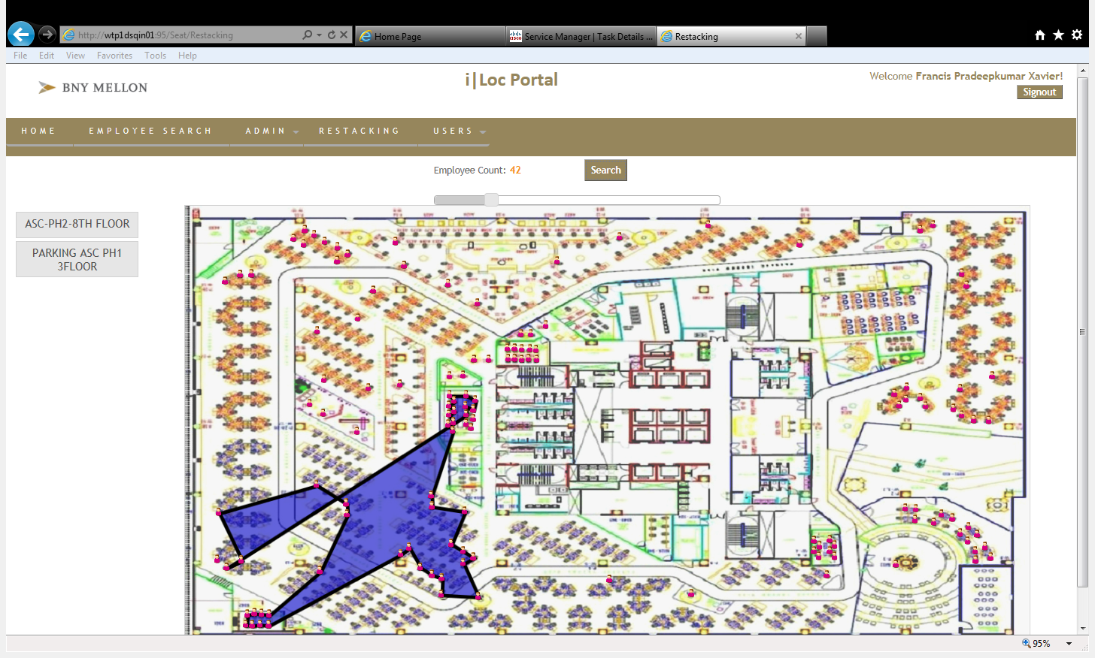

Figure 6.14

The below figure shows the roles of each employee which can be newly added, edited or deleted.

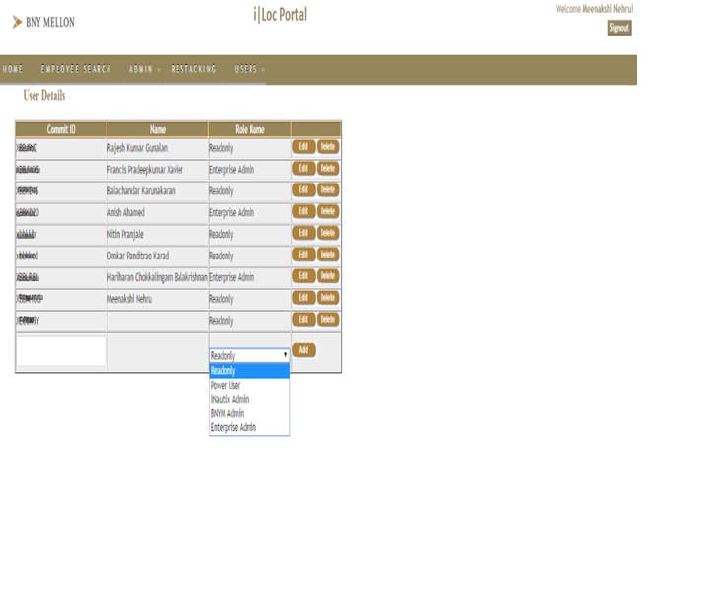Figure 6.15

\

The below figure depicts that we can add,edit or delete the details of employees and assign roles to them

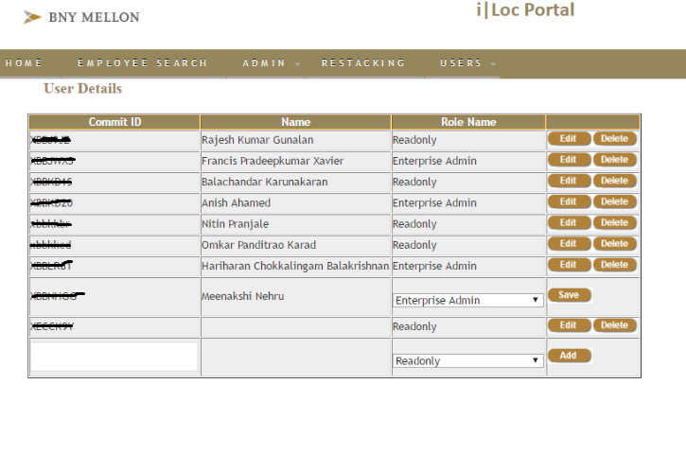

Figure 6.16

The below figure indicating a popup that the changes made successfully.

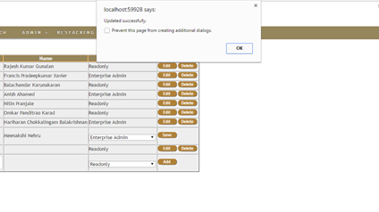Figure 6.17

## CONCLUSION AND FUTURE WORK

## CONCLUSION AND FUTURE WORK

This tool has proposed a web service for location mapping/ restacking any employee of the organization. It provides an efficient manner of locating an employee within a single window view. The administrator uploads the floor map, assigns locations and then allocates the employees to their particular locations using their Commit ID. The employees can view the location of any other employee or can also locate the whole team using the employee’s manager ID. This tool helps in emergency relocation of teams whenever there is a new project allocation.

In future, the tool is going to be expanded for the Global Cash Flow Management for BNY Mellon Company. And also collaborating with the Digital Pulse team, this tool can be explored and put to enterprise usage.

**REFERENCES**

**REFERENCES**

1. P. Bahl and V. N. Padmanabhan. RADAR: An in-building RF-based user location and tracking system. In IEEE Infocom, March 2000.
2. M. H. Jin, H. K. Wu, and J. T. Hormg, "An Intelligent Handoff Scheme Based On Location Prediction Technologies", IEEE European Wireless 2002. pp. 551 - 557, Feb. 2002.
3. Castellanos, J. A., Montiel, J. M. M., Neira, J. and Tard´os, J. D.: 1999, The SPmap: A probabilistic framework for simultaneous localization and map building, IEEE Trans. Robot. Automat. 15(5), 948–953.
4. A Ward, A Jones, A Hopper, “A New Location Technique for Active Office”, IEEE Personal Communications, Vol 4, No 5, Oct 1997.